States of matter Lab practice questions
Butane Lab
1.What is the pressure of a sample of oxygen that is collected over water at 27⁰C if the total pressure of the sample is 778.2 mmHg? (Vapor pressure for 27⁰C = 23.8 mmHg)

2.Find the molar mass of an unknown gas if 0.339 g sample of the gas has a dry pressure (vapor pressure has been accounted for already) of 743.5 mmHg, a volume of 527mL at a temperature of 23⁰C.

3.If the water level inside the graduated cylinder was higher than that outside the cylinder:
- What would be the effect on the pressure of the gas in the cylinder?

- What would be the effect on the resulting molar mass of the gas calculation?

4. Give an example of experimental error in the butane lab and explain the effect on the calculation.

5. Tank A holds 1000 grams of propane C₃H₈ and tank B holds 1000 grams of methane, CH₄. Which tank holds more moles? Show the calculation for each.

Gravimetric analysis
- A 0.051 M solution of Pb(NO₃)₂ is reacted with excess NaCl solution to produce 0.296 grams of solid PbCl₂. What is the original sample volume of Pb(NO₃)₂ used in the reaction?

- A 2.00 gram sample of a compound containing Ba⁺² ion was treated with excess sulfuric acid in order to precipitate out all of the barium sulfate as BaSO₄. If 1.121 grams of BaSO₄, what is the percent mass in the original sample?

- A 0.654 gram sample of impure salt was dissolved in water and reacted with excess AgNO₃, forming 1.26 g of AgCl. What is the percent of NaCl in the impure sample?

- Determine if the effect of the errors in the Molarity in each case in relation to the Gravimetric Analysis of Flint water lab. Explain.

  - White material is present in the filtrate (liquid below filter).

  - The filter paper with product was still wet when massed.

- What color is lead (II) chloride?

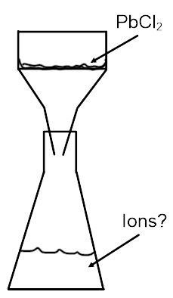
- On the diagram to the right. Label, an ions present in the filtrate.

